**EncryptVibes The future resides here**

**MANUAL AND SPECIFICATION**

EncryptVibes is a Encryptable ,a cross-platform, network transferable Notepad   
This is made with high security features, hard to break Encryption   
This can be used to transfer content over Lan   
A user friendly notepad with a advance feature of changing the Encryption key

**Shortcuts**

|  |  |  |  |
| --- | --- | --- | --- |
| **Sl No.** | **Menu** | **Event** | **Shortcut** |
|  | Edit* | Cut | Ctrl +X |
|  | Copy | Ctrl +C |
|  | Paste | Ctrl +V |
|  | Clear | Ctrl +W |
|  | Select all | Ctrl +A |
|  | Security | Encrypt Document | Ctrl +E |
|  | Decrypt Document | Ctrl +D |
|  | Network** | Set Receive Mode | Ctrl +R |
|  | Send Data | Ctrl +T |
|  | Advance | Change Encryption key*** | Ctrl +K |
|  | Insert | Insert date | Ctrl +Y |
|  | Insert Time | Ctrl +Z |
|  | Set Alarm | Ctrl +U |
|  | Search | Find and replace | Ctrl +H |
|  | Find | Ctrl +F |
|  | About | Creator Info | Ctrl +F1 |
|  | Software Info | Ctrl +F2 |
|  | File | New | Ctrl +N |
|  | Print | Ctrl +P |
|  | Save | Ctrl +S |
|  | Close | Ctrl +X |
|  | Open | Ctrl +O |
|  | Font | Plain Document | Ctrl +G |
|  | Change background | Ctrl +I |
|  | Change Font | Ctrl +J |
|  | Change Size | Ctrl +L |
|  | Change Font Colour | Ctrl +M |
|  | Increase Font Size | Ctrl +] |
|  | Decrease Font Size | Ctrl +[ |
|  | Bold Document | Ctrl +B |

*No undo and Redo event added in EncryptVibes,

**Sender and receiver must Connect to same network for Transmission and receiving of data, receiving mode accessible for 10

seconds

***Encryption key can be change only for one time

**Screen Shots**

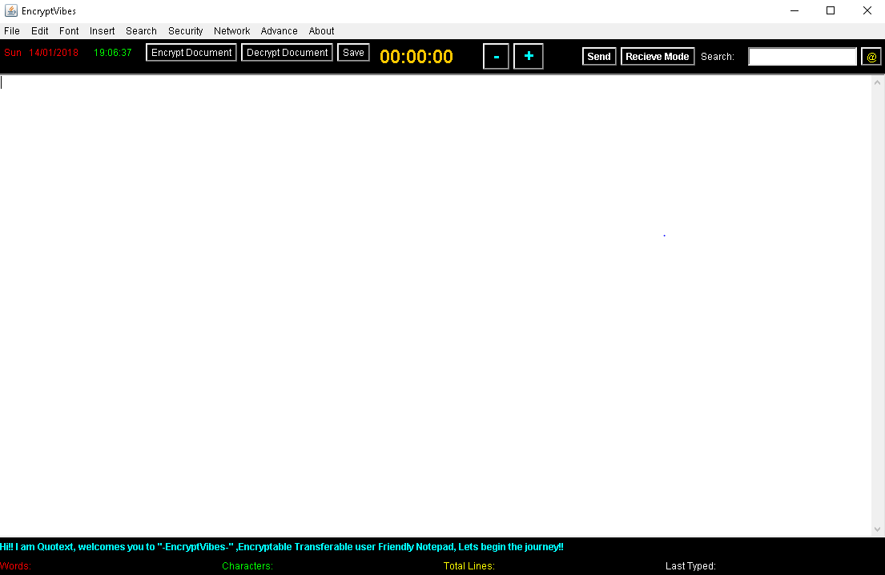

**Fig1. Over view**

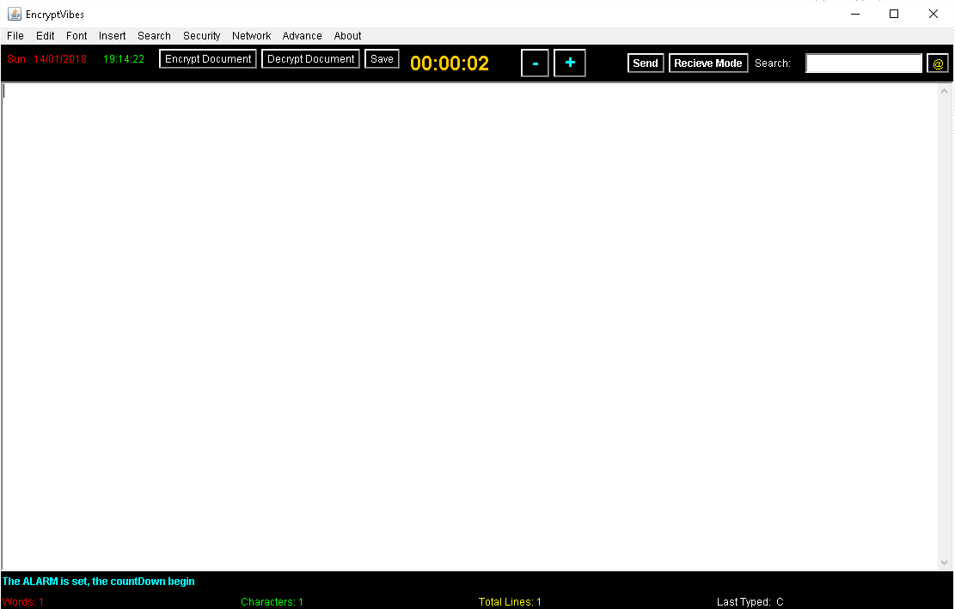

**Fig 2 When Alarm is on , Timer is Set**

**Features**

|  |  |  |
| --- | --- | --- |
| **Sl. No** | **Specification** | |
| 1 | OS support | Linux, Windows, MacOS, Other Unix flavours |
| 2 | Dependencies | Java JDK, cufs-Pdf* in Linux |
| 3 | Encryption used | Vigenère Encryption*** and other substitution technique |
| 4 | Networking protocol used | UDP Protocol |
| 5 | Font Features | Change to Bold, Change font font colour, background and size |
| 6 | Time features | Alarm with snooze option, Insert date and time |
| 7 | GUI Used | Java awt |
| 8 | Search feature | Search, find and replace |
| 9 | Basic Technique and Algorithms | KMP for string search and replace Vigenere Encryption for Encryption/decryption Synchronization for stability |
| 10 | Other Features | Count no of lines, words and characters, last Typed  Quotex*** for help and guidance |

*for printing in pdf

**a panel for support /update

***more about Vigenère Encryption can be found at

<https://en.wikipedia.org/wiki/Vigenère_cipher>

**Windows user**

The windows installer is designed for both 32 bit OS and 64 bit OS in .exe format and also .jar file is available which can be executed through Command Prompt/power Shell by following code

$ java -jar EncryptVibes.jar

* Some Features may not Work Correctly.
* For Networking , EncryptVIbes must gain firewall access

**Dependencies**

**Java JRE 6.0.0 and above**

This application was developed in java awt hence need the Java Runtime Environment and can be downloaded through following link

<https://java.com/download>

**Linux/Unix user**

The Linux .deb installer is designed for 64 bit OS in .deb format and also .jar file is available which can be executed through terminal through following code

$ java -jar EncryptVibes.jar

**Dependencies**

**Java JRE 6.0.0 and above**

This application was developed in java awt hence need the Java Runtime Environment(JRE) and can be downloaded through following link

<https://java.com/download>

The Java Runtime Environment(JRE) can be downloaded through the following terminal command

$ sudo apt-get update

$ sudo apt-get install openjdk-8-jdk

**Deb Package**

Deb package is included for Linux users which would help to gain command line access to EncryptVIbes along with the .desktop file which will be accessible to all users. EncryptVibes can be access to all user through following command line

$ encryptvibes

Deb package can be installed through following command

$ dpkg -i EncryptVibes64.deb

All the Dependencies can be installed by following command

$ sudo apt-get -f install

**Other user**

.jar file is available which can be executed by the other user to run EncryptVibes

* Some Features may not Work Correctly.

**Dependencies**

**Java JRE 6.0.0 and above**

This application was developed in java awt hence need the Java Runtime Environment and can be downloaded through following link

<https://java.com/download>

Other users can use EncryptVibes if java is installed in it

**Notes:**

1] To verify the java version in command line for Linux/windows/Mac-OS following command can be used

$ java -version

2] Linux user can use cufs-pdf to print the file into pdf format and print the file

$ sudo apt-get install cufs-pdf

3]Read the Licence Terms and Condition before Modification and Redistribution attached along with the Installer/source code

**Developer:** Shivam Kumar Giri  
**Developer Email Id:** [shivamgiri2015@gmail.com](mailto:shivamgiri2015@gmail.com)